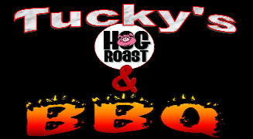
Price List
Hog Roast (Served in a floured bap with stuffing, apple sauce & Crackling)
  - 80 people £700
  - 100 people £800
  - 125 people £850
  - 150 people £900
BBQ (All served in floured baps and bridge rolls, with caramelized onions, cheese and a selection of sauces)
  - Beef Burgers, Jumbo Pork hot dogs £5.95 p/h

Why not add something else? - Pick & Mix: - (Price per item per person)
  - Chicken drumsticks, Chicken kebabs £2.00p/h
  - Vegetable Kebabs, Halloumi Kebabs £1.00p/h
  - Steak, Beef Kebabs, Lamb Kebabs, Salmon Kebabs £2.50 p/h
  - Chips, Onion Rings £1.50 p/h
  - Salads (Mixed leaves, Potato, Mixed bean, tomato, cous cous) £0.50 p/h
  - Tea & Coffee £1.50 p/h
- Hire of equipment 24h Hire
(Delivery and collection free within 10 miles, 40p per mile thereafter).
- A ‘Hog Master’ roast machine £100
- 8’ Folding gas BBQ £80
- 6.5KW Petrol generator (Includes 1 full tank) £80
- Double table top electric fryer (includes oil) £60
- Double electric hob £10
- Chaffing dishes (Including 6 hours fuel) £10
- 30ltr Hot water boilers £20
- 13kg Full Propane gas (Bottle to be returned) £40
- 5ltr Water Containers £1 each
- Portable heated handwash basin £25
- 3m x 3m Gazebo £20
- Utensils (Tongs, Knives, Spatula, Cloths) £1
  - Selection of cold (Soft drink cans) £2.00 p/h
07507501683
Tuckychef@gmail.com

